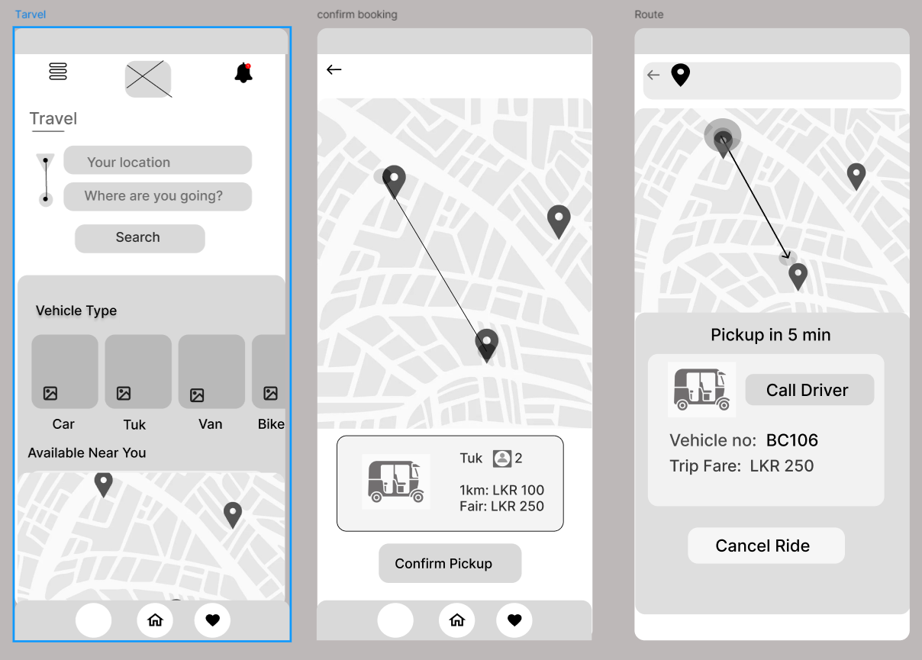

1.Travel

* Users input their current location and destination.
* Select a preferred vehicle type and receive estimated fare and travel time.
* Booking feature with route preview on a map.

2.Stay

* Direct links to major hotel booking platforms for accommodation reservations.

3.Scope

**Objectives**

* To develop a mobile application that serves as a personal travel guide for solo travellers in Sri Lanka.
* To provide curated recommendations for attractions, experiences, and food.
* To integrate essential travel utilities such as maps, weather updates, emergency contacts, and transportation booking.
* To ensure a user-friendly experience with seamless navigation and personalization options.

**Inclusions**

* Place recommendations categorized into Nature & Wildlife, Coastal & Beaches, Cultural & Historical, and Hill Country & Scenic Spots.
* Seasonal experiences based on the user’s travel dates.
* Information on Sri Lanka’s local products ( tea, cinnamon) and where to buy them.
* Local food guide with descriptions and nearby restaurant locations.
* Transport options including vehicle booking and estimated fare details.
* Links to major hotel booking websites for accommodation.
* Cultural norms, etiquette, and safety tips.
* Emergency alerts and quick access to emergency contacts.
* Additional features like a currency exchange tool and travel notes.

**Exclusions**

* Direct hotel booking within the app.
* Flight booking services.
* Social networking features.